A4 | MONDAY DECEMBER 8,2014
Booming Tourism Spurs
YUNNAN DAILY PRESS GROUP
Yunnan’s Economy
By Chu Donghua
In June 2013, the cultural landscapes. Yunnan’s abundant tourism resources
Given its geologic and geomorphologic diversity,
Yunnan is endowed with colourful and picturesque
ists to Yunnan surged: in
August alone, 760 flights
and 97,000 passengers were
handled by Kunming Inter-
national Airport every day
on average.
quet of the Hani people is
a splendid sight. In time
of Spring Festival or other
occasions, hundreds of ta-
bles are arranged in a row
along the street, all laid
with food prepared by all
households in the village
for everyone to enjoy.
landscape of Honghe Hani have brought about unlimited opportunities for far-
Rice Terraces got inscribed sighted business people to invest in its tourism
on the UNESCO World Her- industry.
itage List; on July 2, 2003,
the natural landscape of
T h e h i g h l y d i v e r s e
ecological environment
has nurtured the people
of equally diverse ethnic
groups. China is composed
of 56 ethnic groups and
Yunnan is home to 26 of
them, including 15 ethnic
groups that live nowhere
else in China. A third of the
Yunnan’s population are
of ethnic minorities. The
ethnic customs tours across
the province and the festi-
val tourism tours through-
out the year are dazzling
and unforgettable.
Three Parallel Rivers ac-
quired the World Heritage
status. Altogether, Yunnan
Yunnan’s abundant tour-
ism resources have brought
about unlimited oppor-
tunities for far-sighted
business people to invest
in its tourism industry. It
has assembled a number of
internationally renowned
large enterprises and inves-
tors and hotel management
brands (such as Intercon-
tinental, Starwood, Hilton,
Ho liday Inn, Anantara,
Banyan Tree and Accor).
By 2015, Yunnan expects to
construct, transform and
introduce about 60 hotels
managed by internationally
renowned brands.
has 5 World Heritage Sites
to date, including 3 natural
heritage sites and 2 cultural
Map of World Heritage Sites
in Yunnan
heritage sites.
ers, the most famous of
Yunnan has many riv-
them being the Nu River,
the Lancang River and the
Ji nsha River, which roll
their ways southward and
Old Town of Lijiang
are jointly referred to as
Three Parallel Rivers on
The Old Town of Lijiang in Gu-
cheng District of Lijiang City was in-
the World Natural Heritage
List. Also, the Dulong Riv-
In Yunnan, you can not
only have loads of fun,
but also enjoy numer-
ous delicacies that are
natural and ecological.
E r k u a i , a t y p e o f r i c e
cake known among some
foreigners as “o riental
pizza”, is delicious when
gr illed, boiled, sautéed,
s t e a m e d o r s e r v e d i n
whatever way. Rushan
(milk fan), similar to the
Western cheese, is a sig-
nature food of the Bai
people in Dali. The well-
known Long Street Ban-
scribed on the World Heritage List in
er, the Daying River and
the Ruili River are import-
ant sources and tributaries
of the Irrawaddy River in
Myanmar. The Yuan River
runs south-eastward into
Vietnam. The Lancang
River is the upper part
of the Mekong River that
flows through China, Laos,
Myanmar, Thailand, Cam-
bodia and Vietnam.
Yunnan features a stair-
south, with a large eleva-
tion difference between
the 6,740-metre Kawagebo
Peak and the 76.4-me-
ter river valley in Hekou
County. Yunnan is divid-
ed into seven climatic
zones, including northern
tropical, southern sub-
tropical, mid-subtropical
and northern subtropical
zones. In some places,
you can experience “four
seasons on one trip and
different types of weather
a few miles apart”.
In most parts of Yunnan,
it is neither too cold in win-
ter nor too hot in summer,
and “ever y season offers
stunning scenery for tour-
ists”. When north China be-
comes a world of snow and
ice in winter, black-headed
gulls will migrate from
Siber ia to Kunming, the
capital city of Yunnan. In
summer, Yunnan provides
an escape from hot weath-
er. Last summer when it
was searing hot in other
places, the number of tour-
December 1997. First built in the late
13th century, it stands at an altitude
of over 2,400 metres and covers an
area of some 3.8 square kilometres.
Last year, after more than
thirty years of development,
the value added of Yunnan’s
tourism industry reached
75 billion yuan, account-
ing for 6.4 percent of the
provincial GDP; 5.335 mil-
lion overseas tourists and
over 240 million domestic
tourists brought tourism
revenues to a record high of
over 211.124 billion yuan.
As a historical and cultural site with
comprehensive value, the Old Town
of Lijiang epitomizes the local history, culture and customs. Its buildings have gone
through countless vicissitudes. They have integrated not only the characteristics of
the Han, Bai,Yi and Tibetan cultures but also the architectural style of the Naxi peo-
ple, making them rare legacy for the study of the Chinese architectural and cultural
history.
Natural Landscape of Three Parallel Rivers
stepped terrain. It is high
in the north and low in the
SPA Time in Yunnan
The natural landscape of Three
Parallel Rivers is located in the
northwest of Yunnan Province. It
covers Lijiang City, Diqing Tibetan
Autonomous Prefecture and Nujiang
Lisu Autonomous Prefecture with an
area 41,000 square kilometres and
was recognised as a World Natural
Heritage Site in July 2003. The high
mountains, deep valleys, snow-capped peaks, glaciers, plateaus, wetlands, forests,
prairies and fresh water lakes make up the unique scenery here. This area is home
to more than 20 percent of higher plants and 25 percent of animal species that can
be found in China, so it is also known as“the world biological gene bank”.
Stone Forest
The Stone Forest is located in
Shilin Yi Autonomous County of
Kunming City. It is one of the sites
of South China Karst inscribed on
the World Natural Heritage List in
June 2007. About 300 million years
ago, the region of the Stone Forest
was still a vast expanse of sea. After
long geological evolution, it finally
became the rare geological relic we see today. The Stone Forest covers an area of 350
square kilometres and gathers various types of karst topography on the earth, so
it is known as the “world karst museum”. Stone forests also exist in other places of
the world. Some of them are so remotely located that they can only be watched and
photographed on the plane, and others are hidden in vast woodlands and hardly
reachable. However, the greatest accessibility of the Stone Forest in Yunnan allows
tourists to approach and admire it.
By Zu Hongbing
For Li Bing, a Hebei na-
the time and temporarily
escape from the worldly tri-
fles and urban hustles.
easy.
al sightseeing tourism
shifts to leisure, health
and holidaymaking tour-
ism, Yunnan is attracting
an increasing number of
visitors from both home
and abroad with its SPA
tourism while continual-
ly improving the ser vice
quality. It offers different
SPAs to meet the needs of
different consumers, the
top grade being those of
Kunming Brilliant Resorts
& SPA by Yangzong Lake.
When you come, you can
stay at its aro matic SPA
Villa. Every day after the
SPA, just let the masseuse
run her slender fingers on
your acupoints and have a
sweet dream in the sooth-
ing piano music.
It is Yunnan’s abundant
hot spring resources that
have given birth to this life-
style. In Yunnan, there are
more than 1,200 hot springs,
accounting for a third of
national total. Many of these
hot springs are rich in calci-
um carbonate, magnesium,
sodium, sulphur and other
trace elements, which can
help treat many chronic dis-
eases.
tive who has just settled
in Kunming, Yunnan is an
unusual place with beau-
tiful scenery and relaxing
hot springs. Every month,
Li Bing and his friends
would drive from Kunming
to An’ning to enjoy some
SPA time. Lying in the SPA
pool with a cup of Pu’er tea
and chatting casually with
friends, he would forget
Wild Mushrooms Beat All Delicacies
In Yu nnan, there is a
vogue for SPA. On week-
ends or holidays, many
people living in fast-paced
cities would go take a dip
in hot springs to rid them
of fatigue and relax their
bodies and minds. In urban
and rural areas with hot
springs, SPA is so common
that a single day without
SPA seems to make one un-
Chengjiang Fossil Site
The Chengjiang fossil site is situ-
ated in Maotian Mountain of Cheng-
When you travel to Yun-
nan, make sure you do not
miss the oppor tunity to
wash away your worldly
worries and purify yo ur
body and mind in a SPA
pool.
jiang County, Yuxi City. In July 2012,
it became the only fossil site in China
inscribed on the World Heritage
List under the natural criteria. The
Chengjiang zoolites, dating back to
530 million years ago, was excavated
Today, as the tradition-
in 1984. Its discovery was hailed by
the scientific community as “the most amazing discovery of the twentieth century”
because it solved the mystery of the Cambrian Explosion and located the root of the
tree of life.
By Zu Hongbing
Honghe Hani Rice Terraces
Sp eak ing of Yunnan
russula virecens, boletus
speciosus, porcini, morels
and tea tree mushrooms.
Wild mushrooms are rich in
vitamins and high-quality
protein, making them real
eco food. Wild mushrooms
can be cooked in a hot pot,
sautéed, raw-fried or in-
stant-boiled, and different
cooking methods produce
different tastes.
other. When ser ved with
different dipping sauces,
they will be extremely
tasty.
pepper and garlic. Other
ingredients such as ham or
bacon are also acceptable,
but it is inadvisable to put
in too much of them.
rooms are fragrant, crisp
and mellow.
Honghe Hani Rice Terraces of
Honghe Hani and Yi Autonomous
foods, wild mushrooms are
something not to miss. Yun-
nan has about 250 species
of edible wild mushrooms,
accounting for half of the
world’s total and two-thirds
of national total. From June
to September, wild mush-
rooms will be in season,
including rare species like
matsutake, truffle, termite
and ganba mushrooms
and common species like
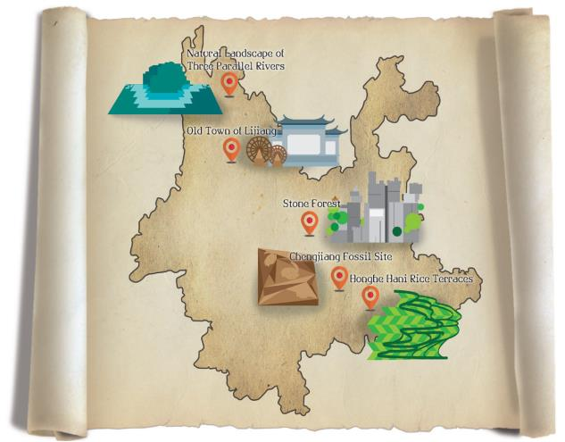
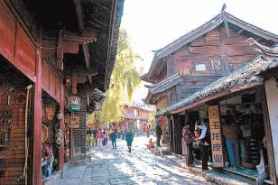
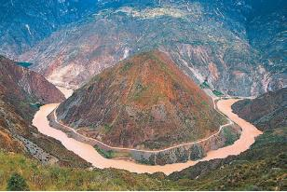
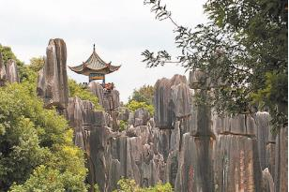
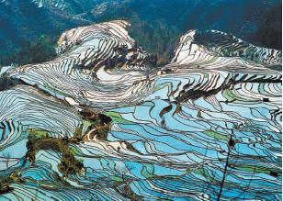
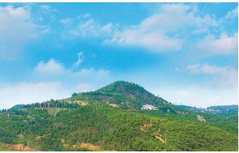
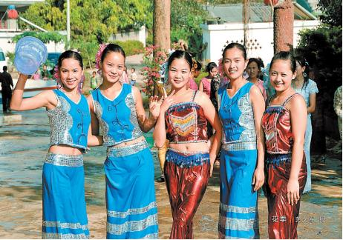
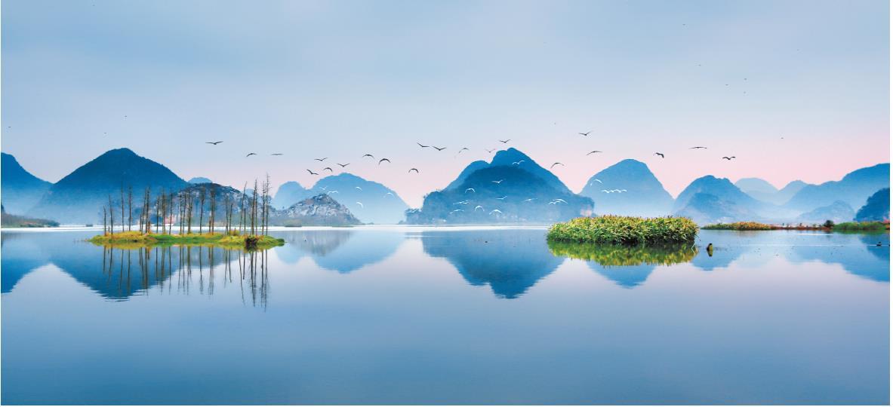
Instant-boiled: This
cooking method can best
retain the original taste of
wild mushrooms. You can
either stir-fry mushrooms
in a small amount of oil
before putting in water
or soup to cook, or wait
till water or soup is boil-
ing before putting in the
mushrooms. Make sure
the seasoning is light to
br ing out freshness and
mellowness.
Prefecture was inscribed on the
Sa utéed: Mushro oms,
especially porcini, ganba
mushrooms and tiger palm
mushrooms, are stir-fried
over high heat in a moder-
ate amount of oil without
adding any water or soup
till they are well-cooked.
T h i s c o o k i n g m e t h o d
can activate the aroma in
mushrooms. Main ingre-
dients include chilli, green
World Heritage List under the cul-
Ra w-fried: This cook-
ing method features high
heat and a large amount
of oil and is suitable for
termite mushrooms, tiger
p a l m m u s h r o o m s a n d
porc ini. In gre dients are
u s u a l l y s e a s o n e d a n d
dra ined before they are
fried in oil till golden
brown. Raw-fried mush-
tural criteria in June 2013. Climbing
over 2,000 meters and up to 3,700
steps from mountain foots to tops,
Honghe Hani Rice Terraces have
been cultivated for more than 1,300
years and are still in use. Within the
cultural landscape of Honghe Hani Rice Terraces are 82 Hani villages, where the an-
cient farming civilization is well-preserved, man and nature live in harmony.
H o t p o t : A s s o r t e d
mushrooms are cooked in
the same pot so that their
aromas complement each
(All photos in Beautiful Yunnan are taken by photographers of Yunnan Daily
Press Group.)

